**Low Level System Design for Retail System**

Designing a low-level retail system involves structuring various components and workflows to handle inventory, transactions, and user management effectively. Here’s a breakdown of some key components and considerations for a typical retail system:

**1. Core Components**

* **Inventory Management**: Tracks items, stock levels, supplier information, and pricing. It should update automatically after transactions to maintain real-time inventory levels.
* **Product Catalog**: Contains detailed information about each product, including description, images, SKU (Stock Keeping Unit), category, and pricing.
* **Order Management**: Manages order creation, order tracking, and returns processing. Integrates with inventory and payment systems to update stock and process payments.
* **User Management**: Manages user profiles for both customers and employees, with different permission levels (e.g., cashier, manager, admin).
* **Payment Processing**: Integrates with payment gateways for secure processing of credit, debit, and other electronic payment methods.
* **Loyalty Program** (optional): Tracks and manages customer loyalty points and redemption options.

**2. Database Schema Design**

* **Tables/Entities**:
  + **Users**: Stores information on user accounts, roles, and permissions.
  + **Products**: Stores product details like SKU, name, description, price, and category.
  + **Inventory**: Tracks stock levels for each product SKU and records stock adjustments (sales, restocks).
  + **Orders**: Contains customer orders with order status, payment status, and details of each item in the order.
  + **Order Items**: Links each order with the products in the order, tracking quantity and unit price.
  + **Payments**: Logs payment transactions, with details of the payment method, amount, status, and order ID.
  + **Loyalty Points** (optional): Tracks customer loyalty points and redemptions.

**3. Workflow Design**

* **Order Placement**:
  1. Customer selects items and adds them to their cart.
  2. The system checks inventory for availability.
  3. The customer proceeds to checkout and selects a payment method.
  4. The payment gateway processes the payment, and the order status is updated based on the result.
  5. The system adjusts inventory levels for purchased items.
* **Inventory Update**:
  1. Regularly check inventory levels to identify low-stock items.
  2. When new stock is received, update the inventory and adjust stock levels accordingly.
  3. Set triggers to notify relevant stakeholders when stock is low.
* **User Authentication and Authorization**:
  1. Authenticate users via sessions or tokens (e.g., JWT for customer-facing systems).
  2. Grant specific permissions based on roles to restrict access to management interfaces (e.g., adding products, updating inventory).

**4. Technology Stack**

* **Backend**: Java with Spring Boot or Node.js with Express for handling business logic.
* **Frontend**: React or Angular for an interactive user interface.
* **Database**: Relational database (e.g., MySQL, PostgreSQL) for transaction consistency; optionally, a NoSQL database (e.g., MongoDB) for handling large product catalogs.
* **Payment Gateway Integration**: Stripe, PayPal, or other APIs for secure transactions.
* **Messaging Queue** (optional): Kafka or RabbitMQ to handle asynchronous tasks, such as email notifications for order confirmations and stock level updates.
* **Caching**: Redis to cache frequently accessed data like product information and inventory to improve response times.
* **Logging and Monitoring**: ELK Stack or Prometheus with Grafana, splunk for tracking system health, error rates, and performance metrics.

**5. Security Considerations**

* **Data Encryption**: Encrypt sensitive data like payment information and personal details.
* **Rate Limiting**: Implement rate limits to prevent abuse of APIs, especially on critical endpoints like login and payment.
* **Authentication and Authorization**: Implement OAuth or JWT for secure user authentication, and enforce role-based access control.

**6. Scalability and Performance Optimization**

* **Database Sharding and Replication**: Split data horizontally for high-traffic tables (e.g., Orders) and replicate databases for read-heavy operations.
* **Load Balancing**: Distribute traffic across multiple application servers to avoid bottlenecks.
* **Horizontal Scaling**: Use container orchestration (e.g., Kubernetes) to scale services horizontally based on demand.

**7. API Design**

* **Product APIs**: Endpoints for listing, searching, and retrieving product details.
* **Inventory APIs**: Endpoints to check inventory levels and update stock.
* **Order APIs**: Endpoints for creating, viewing, updating, and canceling orders.
* **User APIs**: Endpoints for customer login, registration, profile management, and role-based access.
* **Payment APIs**: Endpoints to process payments and handle payment status callbacks.

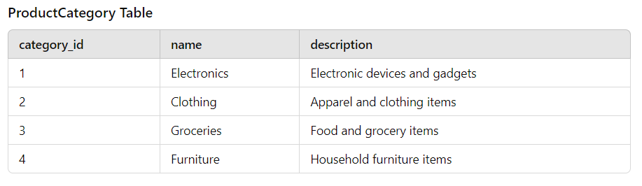

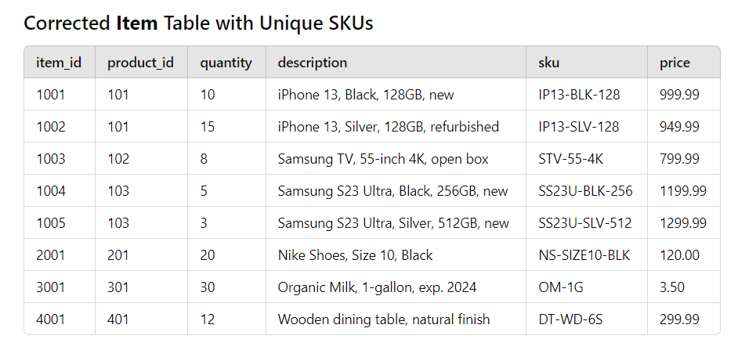

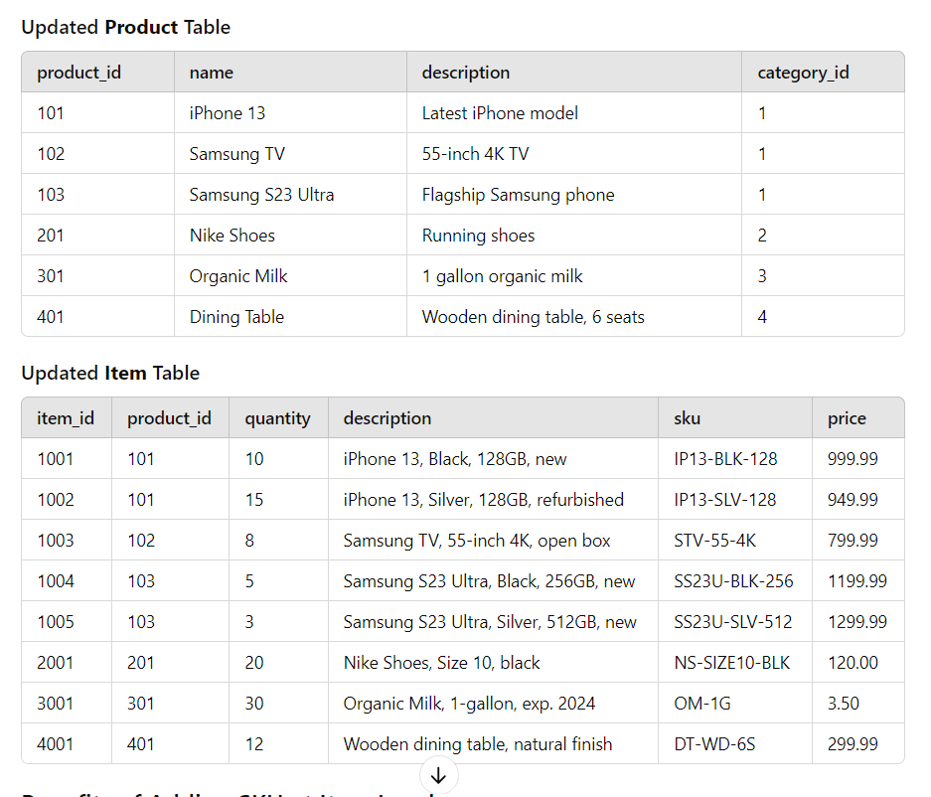

**Using SKU as Primary KEY**

Using SKU as a primary key and establishing relationships with other tables can be a viable approach, but it comes with both benefits and considerations. Here’s an overview of when and how to use SKU in relationships, particularly in the context of an e-commerce system.

**Benefits of Using SKU as a Foreign Key**

1. **Uniqueness**: Since SKUs are unique to each item, using them as foreign keys ensures that you’re always referencing a specific item accurately.
2. **Simplicity**: It simplifies relationships because you can directly use a meaningful identifier (SKU) instead of an arbitrary numeric ID.
3. **Readability**: Queries involving SKUs can be more intuitive, as you can easily identify which item a record relates to.

**Considerations**

1. **Changes to SKU**: If a SKU needs to change due to rebranding or updates in inventory management, it could complicate relationships. This can lead to cascading updates that require careful handling to maintain referential integrity.
2. **Performance**: Depending on the size of your database and the complexity of your queries, using alphanumeric strings (like SKUs) as foreign keys may impact performance compared to using integers. Indexing on SKUs can mitigate this issue, but it's something to keep in mind.
3. **Normalization**: In highly normalized databases, using numeric IDs (like product_id) might be preferred for maintaining relationships, allowing for more straightforward updates and less overhead.

**Example of Relationship Using SKU**

Let’s say we have a **Warehouse** table that manages inventory locations. Here’s how it could look:

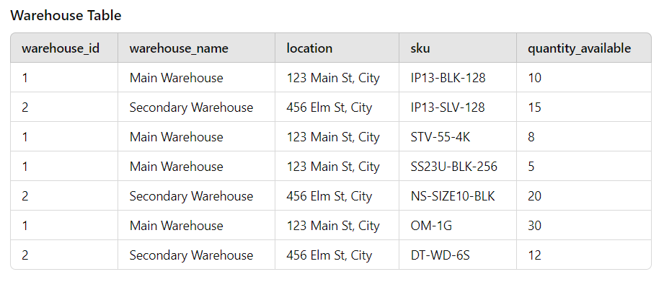

**Foreign Key Relationship**

* In this example, the sku in the **Warehouse** table could serve as a foreign key referencing the sku in the **Item** table.

**SQL Example for Foreign Key**

To establish this relationship, you might define it in SQL like this:

CREATE TABLE Warehouse (

warehouse_id INT PRIMARY KEY,

warehouse_name VARCHAR(255),

location VARCHAR(255),

sku VARCHAR(255),

quantity_available INT,

FOREIGN KEY (sku) REFERENCES Item(sku)

);

**Conclusion**

Using SKU as a foreign key can work well if the benefits align with your application needs. It offers clarity and direct relevance, especially in inventory and order management systems. However, it’s essential to weigh the potential drawbacks, particularly regarding SKU changes and performance, against your specific use case and database design principles. In many cases, a hybrid approach using numeric IDs for certain relationships while keeping SKUs for direct identification can offer a balanced solution.

**5. Transaction Management Between Services**

Managing transactions across distributed services requires a reliable approach for consistency, such as:

**a) Two-Phase Commit (2PC)**

* Useful for handling synchronous transactions between tightly coupled services but can be complex to scale.

**b) Event-Driven Architecture with Event Sourcing**

* Services publish events on critical updates (e.g., Order Created, Payment Processed) to a message broker (e.g., Kafka).
* Other services subscribe to these events and process them asynchronously.
* This approach enhances fault tolerance and scales effectively.

**c) Saga Pattern**

* A distributed transaction pattern where each service handles its portion of a transaction and publishes compensatory actions if a failure occurs.
* Saga is preferred for its resilience in a microservices architecture.

Each service thus processes and maintains transactional consistency independently but communicates via events, ensuring that the retail system handles complex, long-running transactions reliably.

**What is retail application**

A **retail application** is software specifically designed to support the operations of retail businesses, which sell products or services directly to consumers. These applications can be standalone, part of a larger software suite, or integrated into omnichannel systems that cover online, mobile, and in-store experiences.

**Core Functions of Retail Applications**

1. **Inventory Management**: Tracks inventory levels, manages stock in multiple locations, and provides inventory forecasting to prevent stockouts or overstocking.
2. **Order Management**: Manages the lifecycle of customer orders from creation through processing, shipping, and delivery.
3. **Point of Sale (POS)**: Supports in-store transactions, often integrating with hardware like barcode scanners, cash drawers, and receipt printers.
4. **Customer Relationship Management (CRM)**: Manages customer data, tracks purchase history, and helps implement loyalty programs and personalized marketing.
5. **Product Catalog Management**: Organizes product details, prices, categories, and images, enabling easy browsing for customers.
6. **Sales and Promotions**: Manages discounts, promotions, and sales campaigns both in-store and online.
7. **Reporting and Analytics**: Provides insights on sales trends, inventory levels, customer behavior, and other key performance indicators (KPIs).
8. **Payment Processing**: Handles secure processing of customer payments through various methods such as credit/debit cards, mobile wallets, and cash.
9. **Customer Support**: Helps resolve customer queries, process returns, and handle complaints.

**Types of Retail Applications**

* **eCommerce Platforms**: For online retail, allowing customers to browse, shop, and purchase products online.
* **Mobile Apps**: Provide on-the-go shopping experiences, often integrated with mobile payment options and personalized recommendations.
* **In-Store POS Systems**: Facilitate in-person sales, manage cash, and integrate with inventory and loyalty systems.
* **Omnichannel Retail Solutions**: Enable seamless integration of multiple channels (e.g., physical store, website, app) to provide a unified customer experience.

**Example Workflows in a Retail Application**

1. **Customer Browsing and Order Placement**:
   * Customers browse products, add items to their cart, and place an order.
   * The system checks inventory, calculates any discounts, processes the payment, and confirms the order.
2. **Inventory Updates**:
   * When an item is sold or received in stock, inventory levels update in real-time.
   * The application alerts staff for reordering when stock levels are low.
3. **Customer Engagement and Loyalty**:
   * The CRM tracks customer interactions and purchase history, offering personalized recommendations, loyalty points, or discounts.

A well-designed retail application enhances operational efficiency, improves customer satisfaction, and allows for quick adaptation to changing market trends, making it essential for the success of modern retail businesses.

can you explain uses and role of these services used in retail systems - a) User Management Service, b) Product Catalog Service, c) Inventory Management Service, d) Order Management Service, e) Payment Processing Service, f) Shipping and Fulfillment Service, g) Notification Service

Certainly! Each of these services in a retail system plays a distinct role, working together to manage everything from product browsing to order fulfillment and customer communication. Here’s an overview of the purpose and function of each:

**a) User Management Service**

* **Purpose**: Manages all customer and user-related information, such as account creation, authentication, authorization, and profile details.
* **Roles**:
  + **Customer Accounts**: Enables users to create and manage their accounts, including profiles, preferences, and login credentials.
  + **Access Control**: Verifies identity and controls access to different parts of the system based on user roles (e.g., customer, admin, sales associate).
  + **User Data Management**: Stores and retrieves user data for personalized services, order history, and saved payment details.
  + **Security and Authentication**: Protects user information with secure login, password encryption, and potentially multi-factor authentication.

**b) Product Catalog Service**

* **Purpose**: Manages product information, making it accessible to both customers and system components.
* **Roles**:
  + **Product Information**: Stores data about each product, including name, description, price, category, images, and specifications.
  + **Search and Filtering**: Provides search functionality, filtering, and sorting options, allowing users to find products based on categories, price, ratings, etc.
  + **Availability and Pricing**: Tracks product availability and updates pricing or promotions as needed.
  + **Content Updates**: Ensures content consistency by syncing with inventory and promotions, and updates the catalog for new or discontinued products.

**c) Inventory Management Service**

* **Purpose**: Tracks and manages stock levels to ensure products are available for purchase and alerts when reordering is necessary.
* **Roles**:
  + **Stock Levels**: Monitors and updates inventory quantities across multiple warehouses and stores.
  + **Inventory Adjustments**: Adjusts stock levels for activities like sales, returns, and restocks.
  + **Reorder Management**: Triggers reorder processes or alerts for items that reach low stock thresholds.
  + **Inventory Forecasting**: Analyzes demand trends to predict future inventory needs, optimizing stock levels and reducing overstocking.

**d) Order Management Service**

* **Purpose**: Oversees the complete order lifecycle from initiation to fulfillment and provides real-time status updates.
* **Roles**:
  + **Order Creation and Tracking**: Creates orders, assigns order numbers, and tracks status through the stages (e.g., pending, shipped, delivered).
  + **Order Validation**: Validates orders by confirming stock availability and customer information.
  + **Order Modification**: Allows for updates in certain cases, such as address changes, order cancellations, or modifications.
  + **Return and Exchange Management**: Handles customer returns, exchanges, and refund processing.

**e) Payment Processing Service**

* **Purpose**: Facilitates secure transaction processing, ensuring payments are validated, processed, and recorded.
* **Roles**:
  + **Transaction Processing**: Integrates with payment gateways or processors to handle various payment types (e.g., credit/debit cards, e-wallets, bank transfers).
  + **Authorization and Verification**: Validates payment details, checks for fraud, and confirms funds availability.
  + **Refund and Adjustment**: Supports refunds or adjustments in case of order returns, cancellations, or payment issues.
  + **Transaction Security**: Implements secure protocols, like encryption, to protect sensitive financial information.

**f) Shipping and Fulfillment Service**

* **Purpose**: Manages the packing, shipping, and delivery of customer orders, coordinating logistics and tracking.
* **Roles**:
  + **Shipment Scheduling**: Determines shipping options based on customer preference, inventory location, and delivery location.
  + **Tracking and Updates**: Provides tracking numbers, monitors shipment progress, and updates customers on delivery status.
  + **Delivery Management**: Coordinates with carriers for on-time delivery and manages any delivery issues, delays, or address changes.
  + **Return Logistics**: Manages the logistics of returned items, including picking up, restocking, and refunding.

**g) Notification Service**

* **Purpose**: Sends alerts and updates to customers about key events in their order journey, as well as marketing and promotional messages.
* **Roles**:
  + **Order Confirmation and Updates**: Sends order confirmations, shipping updates, and delivery confirmations via email, SMS, or in-app notifications.
  + **Promotions and Marketing**: Delivers promotional content, discounts, and personalized offers to encourage engagement and repeat purchases.
  + **Customer Support Notifications**: Alerts customers to any issues with their orders or account, and provides updates on support tickets or inquiries.
  + **Transactional Notifications**: Informs users about critical account activities like password resets, failed login attempts, and account changes.

**How These Services Work Together**

Each of these services communicates to complete a successful transaction. Here’s an example of how they work together during a typical order flow:

1. **User Browses Catalog**: User Management and Product Catalog services work together to help the user browse products based on preferences.
2. **Order Placement**: When the user places an order, the Order Management Service coordinates with Inventory Management to ensure stock availability.
3. **Payment Processing**: If items are in stock, the Order Management Service triggers the Payment Processing Service to complete the transaction securely.
4. **Shipping Initiation**: After payment confirmation, Order Management requests shipping via the Shipping and Fulfillment Service, which arranges for delivery.
5. **Notifications**: The Notification Service sends updates at each step, keeping the user informed of the order status, shipment, and delivery.

By dividing responsibilities across these services, a retail system can operate more efficiently, manage high volumes, and provide a responsive, seamless experience to users. Each service can also scale independently, handle specific business logic, and respond to user needs promptly.

**Can you list down all entities/actors and their properties for all above services**

Certainly! Here's a breakdown of the key entities and actors involved in each service of a retail system, along with their common properties:

**1. User Management Service**

**Entities**

* **User**
  + userId: Unique identifier for the user.
  + username: User's login name.
  + password: Encrypted password.
  + email: User's email address.
  + phoneNumber: User’s contact number.
  + role: Defines the user type (e.g., customer, admin, support).
  + status: Account status (e.g., active, inactive).
  + createdAt: Date and time of account creation.
  + updatedAt: Date and time of last profile update.
* **Address**
  + addressId: Unique identifier for the address.
  + userId: ID of the user this address belongs to.
  + streetAddress: User's street address.
  + city: City of the address.
  + state: State or province of the address.
  + postalCode: ZIP or postal code.
  + country: Country of residence.
  + isPrimary: Indicates if it’s the primary address.

**2. Product Catalog Service**

**Entities**

* **Product**
  + productId: Unique identifier for the product.
  + name: Product name.
  + description: Detailed description.
  + category: Category under which the product falls.
  + price: Selling price.
  + currency: Currency of the price.
  + createdAt: Date and time when the product was added.
  + updatedAt: Date and time of the last update.
* **Category**
  + categoryId: Unique identifier for the category.
  + name: Category name.
  + parentCategoryId: ID of the parent category (if hierarchical).
  + description: Category description.
* **ProductImage**
  + imageId: Unique identifier for the image.
  + productId: ID of the product the image belongs to.
  + url: URL to the image.
  + altText: Alternate text for accessibility.
  + isPrimary: Indicates if it’s the main image.

**3. Inventory Management Service**

**Entities**

* **InventoryItem**
  + inventoryItemId: Unique identifier for the inventory item.
  + productId: ID of the product in stock.
  + warehouseId: ID of the warehouse location.
  + quantity: Available stock quantity.
  + threshold: Minimum stock level for reordering.
  + lastUpdated: Last updated timestamp.
* **Warehouse**
  + warehouseId: Unique identifier for the warehouse.
  + location: Physical location of the warehouse.
  + capacity: Maximum stock capacity of the warehouse.
* **StockMovement**
  + movementId: Unique identifier for stock movements.
  + inventoryItemId: ID of the item being moved.
  + movementType: Type of movement (incoming, outgoing).
  + quantity: Quantity moved.
  + date: Date of the movement.

**4. Order Management Service**

**Entities**

* **Order**
  + orderId: Unique identifier for the order.
  + userId: ID of the user who placed the order.
  + status: Order status (e.g., pending, shipped, delivered).
  + totalAmount: Total cost of the order.
  + currency: Currency of the transaction.
  + orderDate: Date and time of order placement.
  + updatedAt: Date and time of last status update.
* **OrderItem**
  + orderItemId: Unique identifier for the order item.
  + orderId: ID of the associated order.
  + productId: ID of the product ordered.
  + quantity: Quantity ordered.
  + price: Price per unit at order time.
* **PaymentDetail**
  + paymentId: Unique identifier for the payment.
  + orderId: Associated order ID.
  + amount: Total paid amount.
  + paymentMethod: Method used for payment (e.g., credit card, PayPal).
  + status: Payment status (e.g., completed, failed).
  + transactionId: ID from the payment provider.
  + paymentDate: Date of the transaction.

**5. Payment Processing Service**

**Entities**

* **Payment**
  + paymentId: Unique identifier for the payment.
  + orderId: ID of the associated order.
  + status: Payment status (e.g., pending, completed, failed).
  + amount: Amount to be paid.
  + currency: Currency for the transaction.
  + transactionDate: Date of the transaction.
* **PaymentMethod**
  + methodId: Unique identifier for the payment method.
  + type: Type of payment method (e.g., credit card, wallet).
  + provider: Name of the provider (e.g., Visa, PayPal).
* **Transaction**
  + transactionId: Unique ID for the payment transaction.
  + paymentId: Associated payment ID.
  + status: Status of the transaction.
  + timestamp: Date and time of the transaction.

**6. Shipping and Fulfillment Service**

**Entities**

* **Shipment**
  + shipmentId: Unique identifier for the shipment.
  + orderId: ID of the order being shipped.
  + trackingNumber: Tracking number provided by the carrier.
  + carrier: Shipping carrier (e.g., FedEx, UPS).
  + status: Shipment status (e.g., in transit, delivered).
  + estimatedDeliveryDate: Expected delivery date.
  + shipmentDate: Date of shipment.
* **FulfillmentCenter**
  + centerId: Unique identifier for the fulfillment center.
  + location: Physical location.
  + capacity: Fulfillment center capacity.
* **Return**
  + returnId: Unique identifier for the return.
  + orderId: ID of the order being returned.
  + reason: Reason for the return.
  + status: Return status (e.g., requested, approved).
  + returnDate: Date when the return was initiated.

**7. Notification Service**

**Entities**

* **Notification**
  + notificationId: Unique identifier for the notification.
  + userId: ID of the user receiving the notification.
  + type: Type of notification (e.g., email, SMS, push).
  + content: Message or content of the notification.
  + status: Status (e.g., sent, failed).
  + sentAt: Timestamp of when it was sent.
* **Template**
  + templateId: Unique identifier for the notification template.
  + name: Template name.
  + content: Base content or format for the notification.
  + placeholders: Fields to be replaced dynamically in the template.

**Actors in the Retail System**

1. **Customer**: Interacts with product catalog, places orders, makes payments, and receives notifications.
2. **Admin**: Manages product catalog, inventory, pricing, and user accounts.
3. **Support Agent**: Assists customers with order modifications, returns, and queries.
4. **Warehouse Staff**: Manages inventory and oversees the fulfillment process.
5. **Delivery Partner**: Handles the actual transportation and delivery of orders.
6. **Payment Provider**: Processes customer payments and issues receipts.
7. **Notification System**: Delivers notifications to customers and support staff.

Each of these entities and actors works collaboratively within the retail system to provide a seamless shopping experience, ensure accurate order processing, and facilitate efficient inventory and fulfillment management.

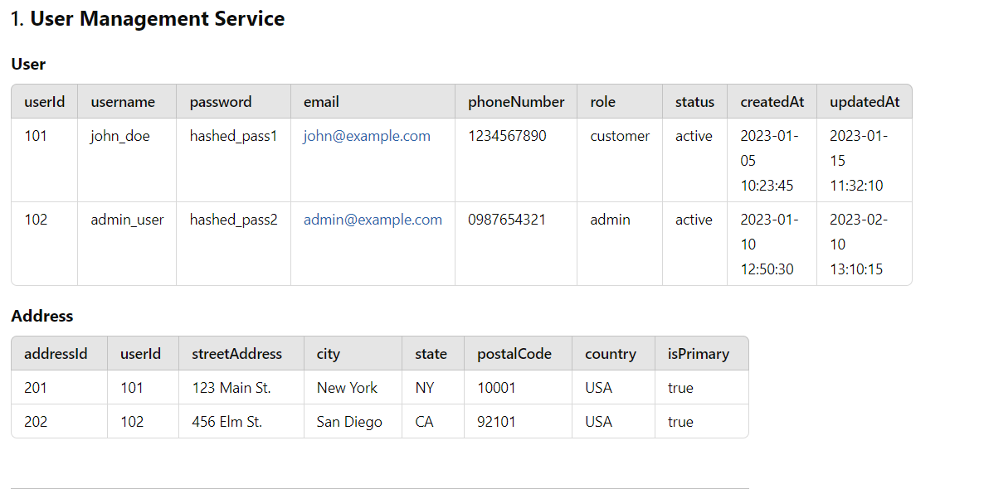

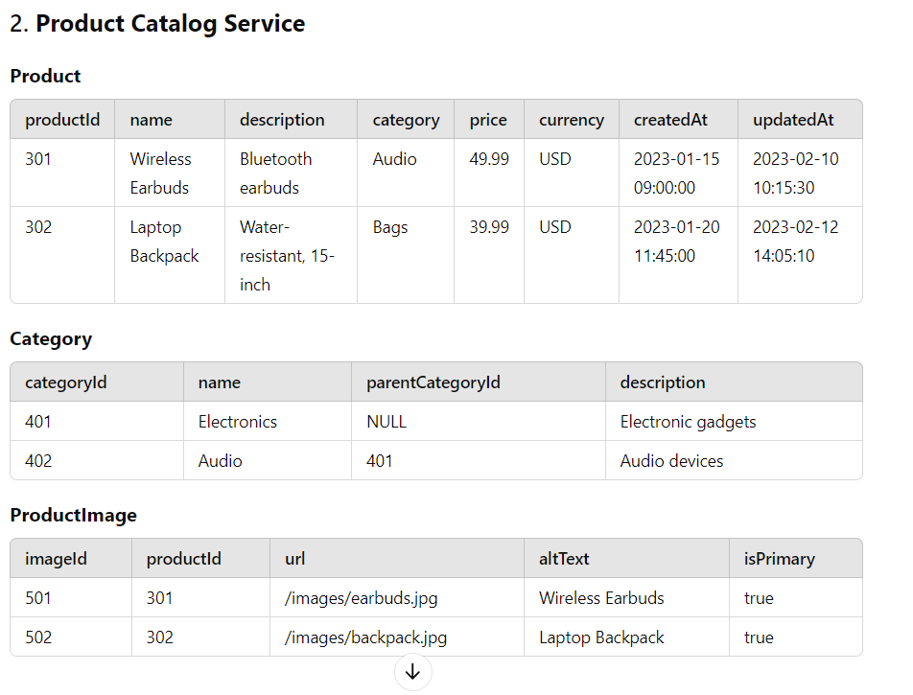

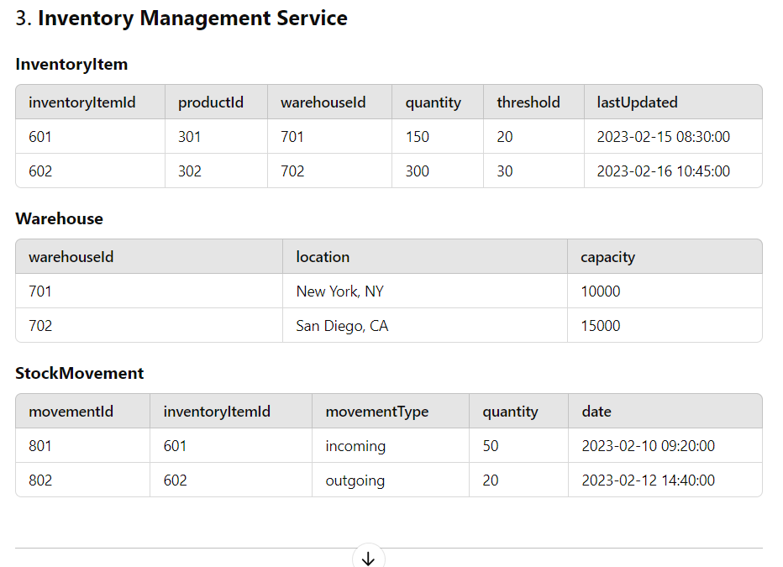

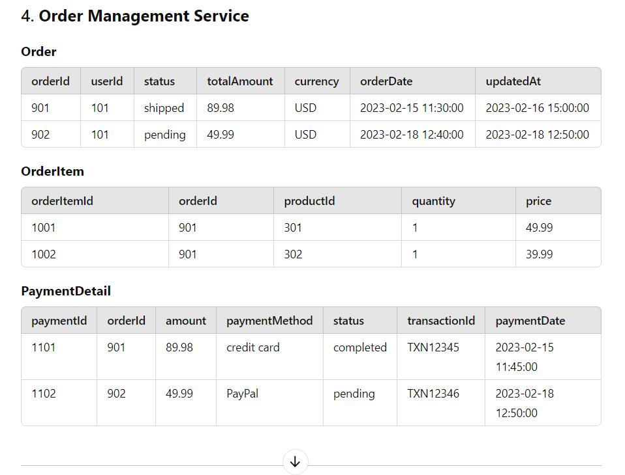

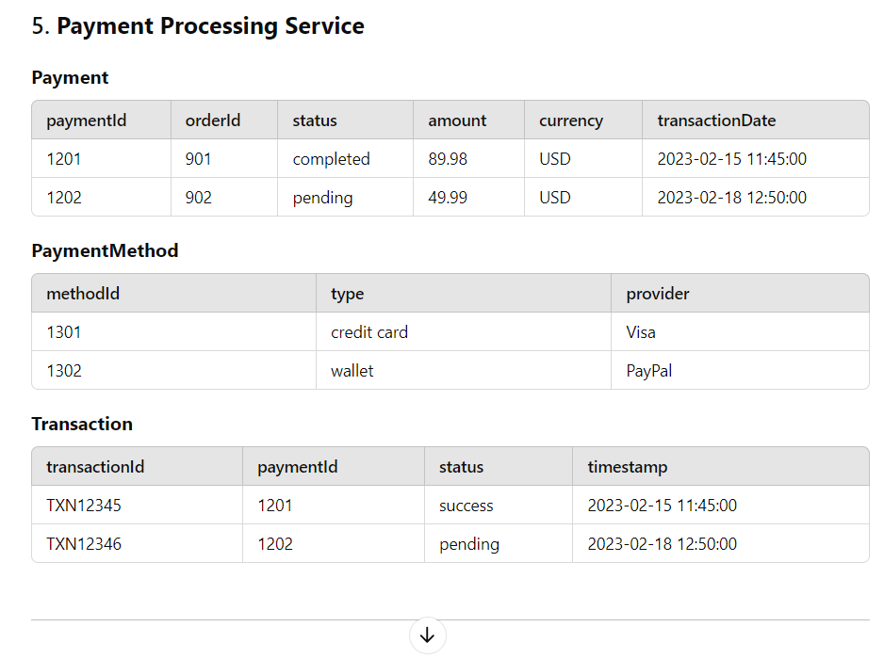

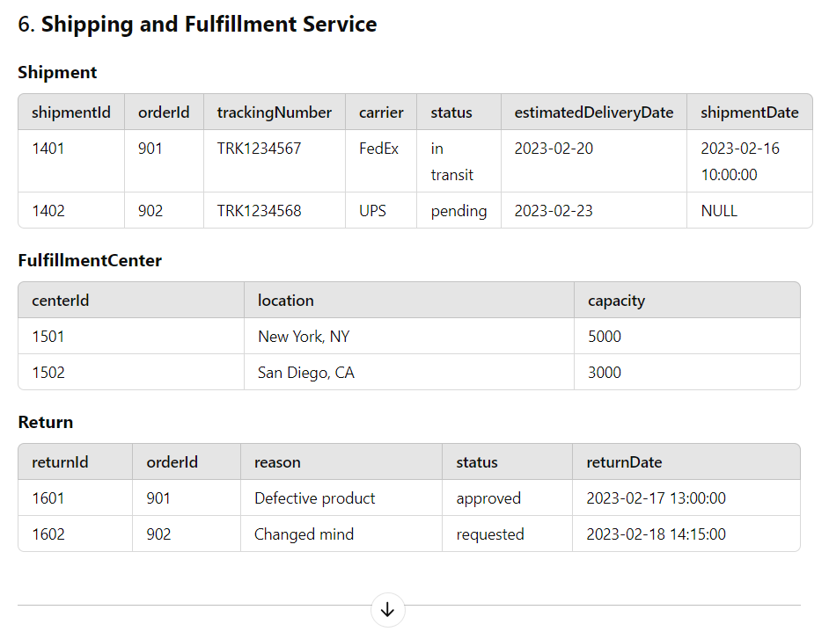

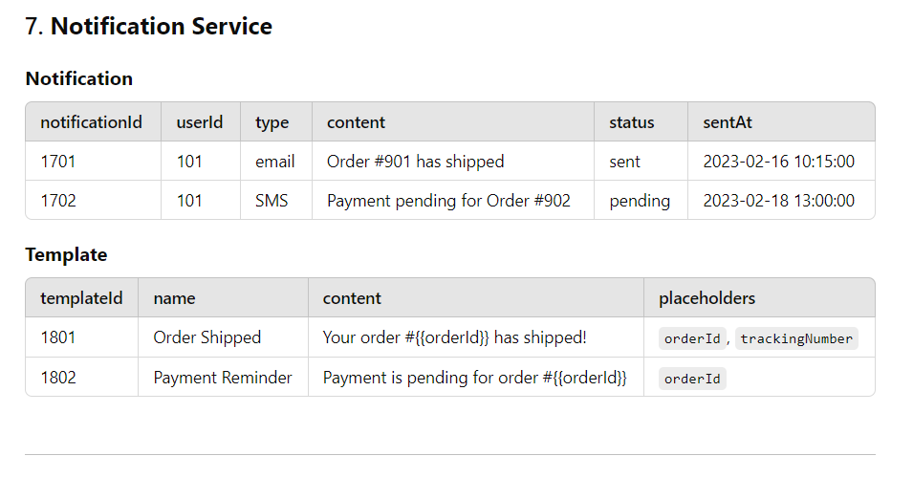

can to stablish relationship between all above enties

Certainly! Establishing relationships between the entities in the retail system is essential for understanding how they interact and depend on one another. Here’s a breakdown of the relationships among the various entities:

**Entity Relationship Diagram (ERD) Relationships**

1. **User Management Service**
   * **User**:
     + **has many** Addresses (1-to-many)
   * **Address**:
     + **belongs to** one User (many-to-1)
2. **Product Catalog Service**
   * **Product**:
     + **belongs to** one Category (many-to-1)
     + **has many** Product Images (1-to-many)
   * **Category**:
     + **has many** Products (1-to-many)
   * **ProductImage**:
     + **belongs to** one Product (many-to-1)
3. **Inventory Management Service**
   * **InventoryItem**:
     + **belongs to** one Product (many-to-1)
     + **belongs to** one Warehouse (many-to-1)
   * **Warehouse**:
     + **has many** InventoryItems (1-to-many)
   * **StockMovement**:
     + **belongs to** one InventoryItem (many-to-1)
4. **Order Management Service**
   * **Order**:
     + **belongs to** one User (many-to-1)
     + **has many** OrderItems (1-to-many)
     + **has one** PaymentDetail (1-to-1)
     + **has one** Shipment (1-to-1)
   * **OrderItem**:
     + **belongs to** one Order (many-to-1)
     + **belongs to** one Product (many-to-1)
   * **PaymentDetail**:
     + **belongs to** one Order (1-to-1)
   * **Shipment**:
     + **belongs to** one Order (1-to-1)
5. **Payment Processing Service**
   * **Payment**:
     + **belongs to** one Order (1-to-1)
     + **has many** Transactions (1-to-many)
   * **Transaction**:
     + **belongs to** one Payment (many-to-1)
6. **Shipping and Fulfillment Service**
   * **Shipment**:
     + **has one** Fulfillment Center (many-to-1)
   * **FulfillmentCenter**:
     + **has many** Shipments (1-to-many)
   * **Return**:
     + **belongs to** one Order (many-to-1)
7. **Notification Service**
   * **Notification**:
     + **belongs to** one User (many-to-1)
   * **Template**:
     + **has many** Notifications (1-to-many)

**Summary of Relationships**

| **Entity** | **Related Entity** | **Relationship Type** |
| --- | --- | --- |
| User | Address | 1-to-many |
| Address | User | many-to-1 |
| Product | Category | many-to-1 |
| Product | ProductImage | 1-to-many |
| Category | Product | 1-to-many |
| ProductImage | Product | many-to-1 |
| InventoryItem | Product | many-to-1 |
| InventoryItem | Warehouse | many-to-1 |
| Warehouse | InventoryItem | 1-to-many |
| StockMovement | InventoryItem | many-to-1 |
| Order | User | many-to-1 |
| Order | OrderItem | 1-to-many |
| Order | PaymentDetail | 1-to-1 |
| Order | Shipment | 1-to-1 |
| OrderItem | Order | many-to-1 |
| OrderItem | Product | many-to-1 |
| PaymentDetail | Order | 1-to-1 |
| Shipment | Order | 1-to-1 |
| Shipment | FulfillmentCenter | many-to-1 |
| FulfillmentCenter | Shipment | 1-to-many |
| Return | Order | many-to-1 |
| Payment | Order | 1-to-1 |
| Payment | Transaction | 1-to-many |
| Transaction | Payment | many-to-1 |
| Notification | User | many-to-1 |
| Template | Notification | 1-to-many |

**Visual Representation**

To visualize these relationships, you would typically use an Entity Relationship Diagram (ERD) where entities are represented as boxes, and relationships are represented as lines connecting those boxes. Each line can be labeled with the nature of the relationship (1-to-many, many-to-1, or 1-to-1) to clarify how entities interact with each other.

**Communication Between Services**

In a microservices architecture, these services typically communicate with each other through APIs. Here’s a simplified overview:

* **User Management Service**: Handles user registration, login, and profile management.
* **Product Catalog Service**: Exposes APIs to retrieve product information and categories.
* **Inventory Management Service**: Provides APIs to check stock levels and manage inventory updates.
* **Order Management Service**: Manages order placement, order status updates, and order history retrieval.
* **Payment Processing Service**: Handles payment processing and transaction tracking.
* **Shipping and Fulfillment Service**: Manages shipment creation and tracking.
* **Notification Service**: Sends notifications to users based on events (e.g., order updates, payment confirmations).

These services communicate over HTTP REST APIs, and message brokers (like Kafka or RabbitMQ) can be used for asynchronous communication and events.

This architecture helps ensure that the retail system is scalable, maintainable, and resilient.

**Can you stablish communication relationship between all above services**

Establishing communication relationships between the services in a retail system is crucial for ensuring that data flows smoothly between them. Below is a breakdown of how these services interact with one another, including the types of communication (synchronous and asynchronous) used in a microservices architecture.

**Communication Relationships Between Services**

1. **User Management Service**
   * **Communicates with**:
     + **Order Management Service**:
       - **Purpose**: To validate user identity and retrieve user information during order placement.
       - **Communication Type**: Synchronous (HTTP REST API).
     + **Notification Service**:
       - **Purpose**: To notify users about account-related events (e.g., registration confirmation).
       - **Communication Type**: Asynchronous (Message Queue).
2. **Product Catalog Service**
   * **Communicates with**:
     + **Order Management Service**:
       - **Purpose**: To provide product details when creating an order and checking product availability.
       - **Communication Type**: Synchronous (HTTP REST API).
     + **Inventory Management Service**:
       - **Purpose**: To update inventory levels when a product is added or modified in the catalog.
       - **Communication Type**: Synchronous (HTTP REST API) or Asynchronous (Message Queue).
3. **Inventory Management Service**
   * **Communicates with**:
     + **Order Management Service**:
       - **Purpose**: To confirm product availability and reserve items during order processing.
       - **Communication Type**: Synchronous (HTTP REST API).
     + **StockMovement**:
       - **Purpose**: To track stock changes (incoming and outgoing).
       - **Communication Type**: Synchronous (HTTP REST API).
4. **Order Management Service**
   * **Communicates with**:
     + **User Management Service**:
       - **Purpose**: To validate user information when an order is placed.
       - **Communication Type**: Synchronous (HTTP REST API).
     + **Payment Processing Service**:
       - **Purpose**: To process payments for orders.
       - **Communication Type**: Synchronous (HTTP REST API).
     + **Shipping and Fulfillment Service**:
       - **Purpose**: To initiate shipment after order payment confirmation.
       - **Communication Type**: Synchronous (HTTP REST API).
     + **Notification Service**:
       - **Purpose**: To send order confirmation and status updates to users.
       - **Communication Type**: Asynchronous (Message Queue).
5. **Payment Processing Service**
   * **Communicates with**:
     + **Order Management Service**:
       - **Purpose**: To confirm payment status after processing.
       - **Communication Type**: Synchronous (HTTP REST API).
     + **Notification Service**:
       - **Purpose**: To send notifications regarding payment success or failure.
       - **Communication Type**: Asynchronous (Message Queue).
6. **Shipping and Fulfillment Service**
   * **Communicates with**:
     + **Order Management Service**:
       - **Purpose**: To receive order details for shipment processing.
       - **Communication Type**: Synchronous (HTTP REST API).
     + **Notification Service**:
       - **Purpose**: To send tracking information and shipment updates to users.
       - **Communication Type**: Asynchronous (Message Queue).
7. **Notification Service**
   * **Communicates with**:
     + **User Management Service**:
       - **Purpose**: To send notifications for account-related events.
       - **Communication Type**: Asynchronous (Message Queue).
     + **Order Management Service**:
       - **Purpose**: To receive notifications for order updates.
       - **Communication Type**: Asynchronous (Message Queue).
     + **Payment Processing Service**:
       - **Purpose**: To send payment-related notifications.
       - **Communication Type**: Asynchronous (Message Queue).

**Summary of Communication Relationships**

| **Source Service** | **Destination Service** | **Purpose** | **Communication Type** |
| --- | --- | --- | --- |
| User Management Service | Order Management Service | Validate user identity | Synchronous (HTTP) |
| User Management Service | Notification Service | Notify users about account events | Asynchronous (MQ) |
| Product Catalog Service | Order Management Service | Provide product details and availability | Synchronous (HTTP) |
| Product Catalog Service | Inventory Management Service | Update inventory levels | Synchronous (HTTP) or Asynchronous (MQ) |
| Inventory Management Service | Order Management Service | Confirm product availability | Synchronous (HTTP) |
| Order Management Service | User Management Service | Validate user information | Synchronous (HTTP) |
| Order Management Service | Payment Processing Service | Process payments | Synchronous (HTTP) |
| Order Management Service | Shipping and Fulfillment Service | Initiate shipment | Synchronous (HTTP) |
| Order Management Service | Notification Service | Send order confirmation and updates | Asynchronous (MQ) |
| Payment Processing Service | Order Management Service | Confirm payment status | Synchronous (HTTP) |
| Payment Processing Service | Notification Service | Send payment notifications | Asynchronous (MQ) |
| Shipping and Fulfillment Service | Order Management Service | Receive order details for shipment processing | Synchronous (HTTP) |
| Shipping and Fulfillment Service | Notification Service | Send tracking information | Asynchronous (MQ) |
| Notification Service | User Management Service | Send notifications for account events | Asynchronous (MQ) |
| Notification Service | Order Management Service | Receive order updates | Asynchronous (MQ) |
| Notification Service | Payment Processing Service | Send payment-related notifications | Asynchronous (MQ) |

**Communication Mechanisms**

* **Synchronous Communication**: Typically done via HTTP REST APIs, where one service makes a direct request to another and waits for a response.
* **Asynchronous Communication**: Often implemented using a message queue (MQ) system, where messages are sent to a queue and processed independently by the receiving service, allowing for decoupled communication.

**Conclusion**

This communication model allows the services to work together effectively, ensuring a smooth flow of data and events throughout the retail system. The combination of synchronous and asynchronous communication helps balance the need for real-time interactions with the scalability and resilience of the system.

**At which stage of the buying product online order entry gets created in database**

In an online e-commerce system, the order entry typically gets created in the database during the checkout process, specifically at the moment when the user confirms their order and initiates payment. Here's a breakdown of the stages involved in this process:

**Stages of the Buying Process**

1. **Product Selection**:
   * The user browses products and adds desired items to their cart.
2. **View Cart**:
   * The user reviews their cart, checking quantities and prices. No order entry is created yet.
3. **Initiate Checkout**:
   * The user proceeds to the checkout page. This may involve creating a temporary session or state for the order, but no order entry is recorded in the database yet.
4. **Enter Shipping and Billing Information**:
   * The user provides shipping and billing details. Again, no order entry is created in the database at this stage.
5. **Review Order Summary**:
   * The user reviews the final order summary, including items, prices, and total amounts. At this point, the system may temporarily hold the order information, but the order entry is still not saved in the database.
6. **Confirm Order (Order Entry Creation)**:
   * **At this stage**, when the user clicks the "Pay Now" button (or a similar confirmation button), the following occurs:
     + The system processes the payment (this may involve a third-party payment gateway).
     + If the payment is successful, the system creates an order entry in the database.
     + This entry typically includes details such as user ID, items purchased, payment status, shipping information, and timestamps.
7. **Post-Payment Processing**:
   * After the order entry is created, additional processing may occur, such as:
     + Sending confirmation emails.
     + Updating inventory levels.
     + Initiating order fulfillment (shipping, packaging).

Below is a detailed API listing for each service involved in the retail system, along with request and response JSON data. The sequence will follow the user journey from browsing products on the homepage to placing an order and making a payment.

**1. Product Catalog Service**

**a. List Products (Homepage)**

* **API Endpoint**: GET /api/products/ userId=123
* **Request**: None
* **Response**:

{

"products": [

{

"id": "101",

"name": "Wireless Mouse",

"description": "Ergonomic wireless mouse with USB receiver.",

"price": 29.99,

"category": "Electronics",

"images": ["url_to_image1", "url_to_image2"],

"availableQuantity": 100

},

{

"id": "102",

"name": "Bluetooth Headphones",

"description": "Noise-cancelling Bluetooth headphones.",

"price": 89.99,

"category": "Electronics",

"images": ["url_to_image3", "url_to_image4"],

"availableQuantity": 50

}

]

}

**b. Get Product Details (PDP)**

* **API Endpoint**: GET /api/products/{userID}/{productId}
* **Request**:

{

“userID”: 11,

"productId": "101"

}

* **Response**:

{

"product": {

"id": "101",

"name": "Wireless Mouse",

"description": "Ergonomic wireless mouse with USB receiver.",

"price": 29.99,

"category": "Electronics",

"images": ["url_to_image1", "url_to_image2"],

"availableQuantity": 100

}

}

**2. Inventory Management Service**

**a. Check Inventory Availability**

* **API Endpoint**: GET /api/inventory/{productId}
* **Request**:

{

"productId": "101"

}

* **Response**:

{

"productId": "101",

"availableQuantity": 100,

"estimatedDeliveryDate": "2024-11-01"

}

**3. Shopping Cart Service**

**a. Add Product to Cart**

* **API Endpoint**: POST /api/cart/add
* **Request**:

{

"userId": "user123",

"productId": "101",

"quantity": 1

}

* **Response**:

{

"message": "Product added to cart",

"cart": {

"userId": "user123",

"items": [

{

"productId": "101",

"quantity": 1,

"price": 29.99

}

],

"totalAmount": 29.99

}

}

**4. Order Management Service**

**a. Checkout**

* **API Endpoint**: POST /api/orders/checkout
* **Request**:

{

"userId": 123,

"items": [

{

"productId": 101,

"sku": "IPHONE13-BLK-128GB",

"quantity": 1,

"unitPrice": 999.99,

"discount": 50.00,

"finalPrice": 949.99

},

{

"productId": 102,

"sku": "SAMSUNG-S23-ULTRA",

"quantity": 1,

"unitPrice": 1199.99,

"discount": 100.00,

"finalPrice": 1099.99

}

],

"subtotal": 2049.98,

"totalDiscount": 150.00,

"totalAmount": 1899.98,

"shippingAddressId": 1,

"billingAddressId": 1,

"selectedPaymentMethod": "CREDIT_CARD",

"paymentDetails": {

"cardNumber": "4111111111111111",

"expiryDate": "12/24",

"cvv": "123"

},

"orderNotes": "Please leave the package at the front door."

}

**Response**:

**{**

**"message": "Order placed successfully.",**

**"orderId": 987654, // New order ID generated**

**"totalAmount": 1899.98,**

**"status": "Pending",**

**"expectedDelivery": "2024-11-01"**

**}**

**5. Payment Processing Service**

**a. Make Payment**

* **API Endpoint**: POST /api/payments
* **Request**:

json

{

"orderId": 987654, // The unique identifier for the order

"userId": 123, // The ID of the user making the payment

"amount": 1899.98, // Total amount to be paid

"currency": "USD", // Currency for the transaction

"paymentMethod": {

"type": "CREDIT_CARD", // Type of payment method

"details": {

"cardNumber": "4111111111111111", // Credit card number

"expiryDate": "12/24", // Card expiry date

"cvv": "123", // Card CVV

"cardholderName": "John Doe" // Name on the card

}

},

"transactionId": "TXN-1234567890", // Unique transaction ID generated by the payment gateway (optional)

"orderNotes": "Order for electronics" // Any notes related to the order

}

* **Response**:

{

"message": "Payment processed successfully.",

"orderId": 987654,

"paymentStatus": "SUCCESS", // The status of the payment

"transactionId": "TXN-1234567890", // The transaction ID from the payment gateway

"confirmationMessage": "Your payment has been confirmed. Thank you for your purchase!",

"expectedDelivery": "2024-11-01"

}

**6. Inventory Management Service (Reduce Inventory)**

**a. Reduce Inventory After Payment**

* **API Endpoint**: POST /api/inventory/reduce
* **Request**:

{

"items": [

{

"productId": 101,

"sku": "IPHONE13-BLK-128GB",

"quantity": 1 // Quantity to deduct

},

{

"productId": 102,

"sku": "SAMSUNG-S23-ULTRA",

"quantity": 1 // Quantity to deduct

}

],

"orderId": 987654 // Reference to the order for tracking

}

* **Response**:

json

Copy code

{

"message": "Inventory updated successfully",

"remainingQuantity": 99

}

**Complete Workflow Summary**

1. **List Products**: User visits the homepage and retrieves a list of available products.
2. **Get Product Details**: User selects a product to view its details, including description, price, and availability.
3. **Check Inventory**: User checks the availability of the selected product and gets an estimated delivery date.
4. **Add to Cart**: User adds the product to their shopping cart.
5. **Checkout**: User proceeds to checkout with the items in the cart and provides a shipping address.
6. **Make Payment**: The user provides payment information, and the system processes the payment.
7. **Reduce Inventory**: After successful payment, the inventory is updated to reflect the sale.

**Final Notes**

* The above APIs illustrate the main interactions in the retail system.
* In a real-world application, additional APIs would be necessary for managing users, processing returns, handling notifications, and managing shipping details, among others.
* Each service would also typically include error handling, authentication, and validation mechanisms to ensure smooth operation.

Handling order processing in a retail system, especially when multiple customers might be attempting to purchase the same limited-quantity product, presents several challenges. Here’s a detailed explanation of how the system can effectively manage these scenarios, including the potential challenges and their solutions, along with the communication methods used.

**Order Processing Workflow**

1. **User Selection**: A customer selects a product to order. The system checks the current inventory to see if the item is available.
2. **Inventory Check**: The system checks the available quantity of the selected product.
3. **Place Order**: If the product is available, the order is placed, which may involve reserving the item in the inventory for that customer.
4. **Payment Processing**: The system processes the payment. Depending on the outcome (success or failure), it takes different actions.

**Challenges and Solutions**

**1. Concurrency Issues (Race Conditions)**

* **Challenge**: Multiple customers try to place orders for the same product simultaneously, leading to situations where more than one order can be placed for a product with limited stock.
* **Solution**:
  + **Optimistic Locking**: Implement a versioning system for inventory records. When a customer attempts to place an order, the system checks the version of the inventory record. If the version has changed since the inventory was fetched, the order fails, and the customer is notified to try again.
  + **Synchronous Communication**: When checking inventory before processing an order, use synchronous communication (HTTP REST API) to ensure that the inventory state is always up to date.

**2. Payment Failures**

* **Challenge**: Payment could fail due to network issues, insufficient funds, or other problems.
* **Solution**:
  + **Two-Phase Commit**: Implement a two-phase commit for transactions involving payment and inventory updates. Initially, reserve the inventory for a short time while processing the payment. If the payment fails, release the inventory back to stock.
  + **Asynchronous Notifications**: If the payment fails, notify the customer through the notification service asynchronously, allowing them to retry the payment.

**3. Successful Payment but Unsuccessful Order**

* **Challenge**: The payment may succeed (the amount is deducted), but the order processing may fail (e.g., due to inventory issues).
* **Solution**:
  + **Compensating Transactions**: If an order fails after payment, initiate a compensating transaction to refund the payment. This can be handled using the payment processing service which should maintain the state of transactions.
  + **Event Sourcing**: Maintain an event log that tracks all actions. If an order fails post-payment, use the event log to trigger a refund process.

**4. Network Issues**

* **Challenge**: Network issues can lead to communication failures between services, causing either delays or incomplete transactions.
* **Solution**:
  + **Retries and Backoff**: Implement retry mechanisms with exponential backoff for transient errors during payment processing or order placement.
  + **Circuit Breaker Pattern**: Use a circuit breaker pattern to prevent the system from making requests to a service that is known to be failing.

**Communication Methods**

1. **Synchronous Communication**:
   * Used for critical operations where the state needs to be checked immediately (e.g., checking inventory before placing an order).
   * Ensures that the order is processed based on the latest inventory state.
2. **Asynchronous Communication**:
   * Used for notifications (e.g., informing customers of payment failures, order confirmations) where immediate responses are not required.
   * Allows the system to handle operations in the background without blocking the user experience.

**Example Workflow with Handling Mechanisms**

1. **User Requests to Purchase Product**:
   * The system checks the inventory (synchronous API call).
   * If inventory is available, the system reserves the product (optimistic locking).
2. **Payment Processing**:
   * The payment is processed (synchronous API call to payment service).
   * If successful, the system updates the inventory (synchronous API call).
   * If the payment fails, notify the user and release the reserved inventory.
3. **Post-Payment Order Confirmation**:
   * If the order is successful, confirm to the user (asynchronous notification).
   * If the order fails after payment (due to inventory issues), initiate a refund process (compensating transaction) and notify the user.

Selecting the right database for each service in a retail system is crucial for performance, scalability, and reliability. Here's a list of suitable databases for each service, along with the reasons for their selection:

**1. User Management Service**

* **Database**: **Relational Database (e.g., PostgreSQL or MySQL)**
  + **Reason**: User management often requires complex queries, relationships, and data integrity. Relational databases excel at handling structured data and enforcing constraints like unique email addresses and password hashes.

**2. Product Catalog Service**

* **Database**: **NoSQL Database (e.g., MongoDB)**
  + **Reason**: Product catalogs can have varying attributes and require flexibility in data modeling. NoSQL databases like MongoDB allow for easy updates to product schemas and are well-suited for handling large volumes of unstructured or semi-structured data.

**3. Inventory Management Service**

* **Database**: **Relational Database (e.g., PostgreSQL)**
  + **Reason**: Inventory management requires precise tracking of stock levels, and relational databases provide strong ACID properties, ensuring consistency and reliability when managing inventory levels and reservations.

**4. Order Management Service**

* **Database**: **Relational Database (e.g., PostgreSQL)**
  + **Reason**: Order management requires complex transactions, data integrity, and relationships (e.g., between orders, users, products, and payments). A relational database is ideal for maintaining these relationships and ensuring consistency through transactions.

**5. Payment Processing Service**

* **Database**: **Relational Database (e.g., PostgreSQL or MySQL)**
  + **Reason**: Payment processing involves sensitive financial data and requires strong transactional support. Relational databases are suitable for ensuring data integrity and consistency during payment transactions, especially with ACID compliance.

**6. Shipping and Fulfillment Service**

* **Database**: **NoSQL Database (e.g., MongoDB or DynamoDB)**
  + **Reason**: Shipping data can vary widely in structure, and a NoSQL database can provide flexibility. It can easily handle large volumes of data related to shipping statuses, tracking numbers, and fulfillment locations without needing a strict schema.

**7. Notification Service**

* **Database**: **NoSQL Database (e.g., Redis or MongoDB)**
  + **Reason**: The notification service may require quick reads and writes for delivering messages or alerts to users. Redis, as an in-memory data store, is suitable for high-speed message delivery, while MongoDB can be used for storing notification logs.

**Summary of Database Selections**

| **Service** | **Recommended Database** | **Reason for Selection** |
| --- | --- | --- |
| User Management Service | PostgreSQL / MySQL | Strong ACID properties, relational data integrity, and complex queries. |
| Product Catalog Service | MongoDB | Flexible schema design, handling large volumes of unstructured or semi-structured data. |
| Inventory Management Service | PostgreSQL | Reliable tracking of stock levels with ACID properties for consistency. |
| Order Management Service | PostgreSQL | Supports complex transactions and relationships between orders, users, and products. |
| Payment Processing Service | PostgreSQL / MySQL | Ensures data integrity and consistency for sensitive financial transactions. |
| Shipping and Fulfillment Service | MongoDB / DynamoDB | Flexibility in data structure and handling large volumes of varying shipping data. |
| Notification Service | Redis / MongoDB | High-speed reads/writes for message delivery; suitable for logging notifications. |

This selection aims to provide a balance between performance, scalability, and reliability across different services within a retail system, taking into account the specific requirements and characteristics of each service.

**you know retail system may have offline stores so how inventory are managed globaly**

**ChatGPT said:**

ChatGPT

Managing inventory across both online and offline retail channels in a global retail system involves a complex interplay of systems and processes. Here's how inventory can be effectively managed globally in such a hybrid retail environment:

**1. Centralized Inventory Management System**

* **Unified Database**: Implement a centralized inventory management system (IMS) that consolidates inventory data from all channels (online and offline) into a single database. This helps maintain real-time visibility of inventory levels across all locations.
* **Multi-Location Support**: The system should support multiple warehouses and store locations, allowing for tracking inventory levels and movements at each site.

**2. Real-Time Inventory Updates**

* **Inventory Synchronization**: Use real-time inventory synchronization techniques to ensure that changes in inventory levels (sales, returns, transfers) are reflected immediately across all channels. This can be achieved using APIs or messaging systems (like Kafka or RabbitMQ) to communicate updates between systems.
* **Webhooks**: Implement webhooks that trigger updates to inventory levels when a sale is made in either an online or offline store.

**3. Inventory Visibility**

* **Dashboard and Reporting Tools**: Provide retailers with dashboards that display real-time inventory levels, sales trends, and stockouts. This visibility helps in making informed decisions regarding restocking and managing inventory across locations.
* **Alerts and Notifications**: Set up alerts for low inventory levels or stockouts to proactively manage replenishment.

**4. Inventory Allocation and Fulfillment**

* **Automated Allocation**: Use algorithms to allocate inventory based on demand forecasts, sales trends, and historical data. This can optimize stock levels across different locations, ensuring that popular items are adequately stocked where demand is highest.
* **Cross-Channel Fulfillment**: Enable cross-channel fulfillment strategies, such as:
  + **Buy Online, Pick Up In-Store (BOPIS)**: Allow customers to buy products online and pick them up at their nearest store, which can help in managing inventory efficiently.
  + **Ship from Store**: If an online order comes in for a product that's available at a nearby store, it can be fulfilled from that store rather than a distant warehouse, reducing shipping times.

**5. Inventory Auditing and Reconciliation**

* **Regular Audits**: Conduct regular inventory audits and cycle counts to reconcile physical inventory with system data. This helps identify discrepancies and prevent stock losses.
* **Integration with POS Systems**: Ensure that Point of Sale (POS) systems at offline stores are integrated with the centralized IMS. This integration allows for automatic updates to inventory levels when sales are made.

**6. Demand Forecasting and Planning**

* **Advanced Analytics**: Implement data analytics and machine learning algorithms to analyze historical sales data, customer behavior, and market trends for demand forecasting. This can help in planning inventory levels more accurately across all channels.
* **Seasonal and Trend Analysis**: Adjust inventory levels based on seasonal trends, holidays, and promotions to optimize stock availability.

**7. Returns Management**

* **Streamlined Returns Process**: Manage returns effectively by allowing customers to return products purchased online at offline locations and vice versa. Ensure that returned items are promptly processed back into inventory.
* **Quality Checks**: Implement quality checks for returned items to assess their condition before reintegrating them into the inventory.

**8. Supply Chain Integration**

* **Collaboration with Suppliers**: Maintain close relationships with suppliers to improve lead times and inventory replenishment processes. Use a vendor-managed inventory (VMI) approach where suppliers manage inventory levels at the retailer’s location.
* **Global Sourcing and Logistics**: For global operations, manage sourcing and logistics to ensure that inventory is available where it's needed, taking into account lead times and demand patterns across different regions.

**Conclusion**

Managing inventory globally across both online and offline stores requires a robust and integrated system that provides real-time visibility, facilitates efficient operations, and supports decision-making. By leveraging centralized inventory management, advanced analytics, and effective cross-channel fulfillment strategies, retailers can optimize their inventory levels, reduce costs, and enhance customer satisfaction.

inventory system design low level design with entity relationship mappings explain all services and components

Designing a low-level inventory system involves defining all the services, components, and relationships necessary to manage product stock levels, suppliers, warehouses, and transactions. Here’s a detailed breakdown, covering services, components, and entity-relationship mappings.

**Core Components of the Inventory System**

1. **Product Management**: Manages product details and specifications.
2. **Inventory Management**: Manages stock levels, locations, and stock adjustments.
3. **Supplier Management**: Manages supplier information and relationships.
4. **Warehouse Management**: Manages warehouses and the stock in each location.
5. **Order Management**: Manages stock inflow/outflow from purchase orders (suppliers) and sales orders (customers).
6. **Notification Service**: Sends alerts for low stock, restocks, or reorder levels.
7. **Reporting & Analytics**: Provides data insights on stock levels, sales, and inventory turnover.

**Entity-Relationship Diagram (ERD)**

**Entities**:

1. **Product**
   * **Attributes**: product_id, name, description, category, unit_price, SKU
   * **Relationships**:
     + **One-to-Many** with Inventory: Each product can have multiple stock records in different warehouses.
     + **One-to-Many** with Supplier: Each product can have multiple suppliers.
2. **Inventory**
   * **Attributes**: inventory_id, product_id, warehouse_id, stock_level, reorder_level, last_updated
   * **Relationships**:
     + **Many-to-One** with Product: Multiple inventory entries can refer to the same product.
     + **Many-to-One** with Warehouse: Each inventory entry belongs to a specific warehouse.
3. **Warehouse**
   * **Attributes**: warehouse_id, location, capacity
   * **Relationships**:
     + **One-to-Many** with Inventory: A warehouse can manage stocks for multiple products.
     + **Many-to-One** with Supplier: Warehouses receive products from various suppliers.
4. **Supplier**
   * **Attributes**: supplier_id, name, contact_details, product_ids
   * **Relationships**:
     + **Many-to-Many** with Product: A supplier can supply multiple products, and a product can be supplied by multiple suppliers.
5. **Order**
   * **Attributes**: order_id, order_date, status, order_type (e.g., purchase or sales), warehouse_id
   * **Relationships**:
     + **One-to-Many** with OrderItems: Each order can have multiple items.
     + **Many-to-One** with Warehouse: Each order belongs to a specific warehouse.
6. **OrderItems**
   * **Attributes**: order_item_id, order_id, product_id, quantity, unit_price
   * **Relationships**:
     + **Many-to-One** with Order: Multiple order items belong to a single order.
     + **Many-to-One** with Product: Each order item is associated with a specific product.

**Services and Their Responsibilities**

**1. Product Management Service**

* **Responsibilities**: Handles CRUD operations for products, maintains product details, and integrates with Inventory Management to update stock information based on product additions or discontinuations.
* **API Endpoints**:
  + POST /products - Add a new product.
  + GET /products/{id} - Get product details.
  + PUT /products/{id} - Update product details.
  + DELETE /products/{id} - Remove a product.

**2. Inventory Management Service**

* **Responsibilities**: Manages stock levels, updates inventory based on transactions, and sets reorder levels to automate restocking notifications.
* **Processes**:
  + **Stock Adjustment**: Updates stock levels in response to sales, returns, and transfers.
  + **Low Stock Alerts**: Triggers notifications when stock falls below the reorder level.
* **API Endpoints**:
  + GET /inventory/{productId}/{warehouseId} - Get stock level for a product in a specific warehouse.
  + POST /inventory - Add new stock for a product in a warehouse.
  + PUT /inventory/{id} - Update stock levels manually (for adjustments).
  + GET /inventory/low-stock - List items below reorder level.

**3. Supplier Management Service**

* **Responsibilities**: Maintains supplier records, manages the supplier-product relationship, and tracks product availability from suppliers.
* **Processes**:
  + **Supplier-Product Mapping**: Maps products with suppliers for reordering.
  + **Supplier Contact & Pricing**: Stores supplier contact information and price lists.
* **API Endpoints**:
  + POST /suppliers - Register a new supplier.
  + GET /suppliers/{id} - Retrieve supplier details.
  + PUT /suppliers/{id} - Update supplier information.
  + GET /suppliers/products/{productId} - Get suppliers for a specific product.

**4. Warehouse Management Service**

* **Responsibilities**: Manages warehouses, including their capacity, and tracks which products are stored in which warehouse.
* **Processes**:
  + **Stock Transfer**: Manages stock transfers between warehouses.
  + **Capacity Checks**: Ensures warehouse capacity is not exceeded.
* **API Endpoints**:
  + POST /warehouses - Add a new warehouse.
  + GET /warehouses/{id} - Get warehouse details.
  + PUT /warehouses/{id} - Update warehouse information.
  + POST /warehouses/{id}/transfer - Transfer stock between warehouses.

**5. Order Management Service**

* **Responsibilities**: Manages sales and purchase orders, including tracking and fulfillment processes. It coordinates with Inventory Management to adjust stock levels based on order types.
* **Processes**:
  + **Sales Orders**: Decreases inventory upon fulfillment.
  + **Purchase Orders**: Increases inventory upon receipt of goods.
* **API Endpoints**:
  + POST /orders - Create a new order.
  + GET /orders/{id} - Retrieve order details.
  + PUT /orders/{id} - Update order status (e.g., “fulfilled”, “in-transit”).
  + POST /orders/{id}/items - Add items to an order.

**6. Notification Service**

* **Responsibilities**: Monitors inventory levels, reorder points, and other triggers to send notifications to relevant stakeholders.
* **Processes**:
  + **Low Stock Alert**: Sends notifications when items fall below reorder levels.
  + **Restock Alert**: Sends alerts when items are restocked.
* **API Endpoints**:
  + POST /notifications/low-stock - Trigger low stock notifications.
  + POST /notifications/restock - Notify restock completion.

**7. Reporting & Analytics Service**

* **Responsibilities**: Provides real-time reports on inventory health, turnover rates, and stock levels. It also analyzes stockouts and reorder patterns.
* **Processes**:
  + **Inventory Turnover Report**: Tracks how quickly inventory is moving.
  + **Stock Availability Report**: Shows current stock levels across warehouses.
* **API Endpoints**:
  + GET /reports/inventory-turnover - Get inventory turnover report.
  + GET /reports/stock-levels - Get current stock levels by product and warehouse.
  + GET /reports/stockout-analysis - Analyze frequency of stockouts by product.

**Workflow Examples**

**Product Addition**

1. **Product Management** creates a new product.
2. **Inventory Management** initializes stock levels for each warehouse.
3. **Supplier Management** updates supplier-product mappings.

**Order Placement and Stock Adjustment**

1. A **Sales Order** is created in the **Order Management** system.
2. **Order Management** coordinates with **Inventory Management** to decrease stock levels in the specified warehouse.
3. **Notification Service** checks reorder points and sends alerts if any product is low in stock.

**Stock Reorder Process**

1. **Notification Service** triggers reorder alerts when stock reaches a reorder level.
2. **Order Management** creates a **Purchase Order** with **Supplier Management**.
3. **Inventory Management** increases stock levels upon order fulfillment.

This system design provides a comprehensive and modular approach to managing an inventory system. By defining clear services, relationships, and workflows, it can be easily scaled and extended with additional features.

4o

**You said:**

what does it mean by inventory

**ChatGPT said:**

ChatGPT

Inventory refers to the items, goods, or materials a business holds in stock for the purpose of sale, production, or operations. In a business context, inventory is an asset that needs to be carefully managed to meet customer demand without overstocking or understocking. Inventory can include:

1. **Raw Materials**: Basic materials that will be used to produce goods (e.g., wood, metal, fabric).
2. **Work-in-Progress (WIP)**: Partially finished goods that are in the process of production.
3. **Finished Goods**: Completed products ready to be sold to customers.
4. **MRO Inventory**: Maintenance, Repair, and Operations (MRO) supplies used in production and operations (e.g., tools, office supplies).

**Why Inventory Management Matters**

Inventory management ensures that a business has the right products in the right quantities at the right time. Efficient inventory management helps in:

* **Meeting Demand**: Having enough products to fulfill customer orders promptly.
* **Minimizing Costs**: Reducing storage costs, minimizing stockouts, and avoiding excess inventory.
* **Improving Cash Flow**: Maintaining balanced inventory levels to avoid cash being tied up in unsold products.
* **Enhancing Customer Satisfaction**: Reducing delivery times and preventing backorders.

**Types of Inventory Management Strategies**

1. **Just-in-Time (JIT)**: Ordering stock only when needed to minimize storage costs.
2. **Economic Order Quantity (EOQ)**: Calculating the optimal order quantity to minimize costs.
3. **ABC Analysis**: Categorizing inventory based on importance and usage frequency (e.g., A items are high-value, B items are moderate, C items are low-value).
4. **FIFO and LIFO**: FIFO (First-In-First-Out) and LIFO (Last-In-First-Out) are methods to manage the flow of inventory and its valuation.

Inventory management is critical in various sectors, including retail, manufacturing, and logistics, where effective stock control can significantly impact operational efficiency and profitability.

4o

**You said:**

system design for order management system explain woth entity relationship and required services api's and how they communicate each other to successfully completing order

**ChatGPT said:**

ChatGPT

An **Order Management System (OMS)** is a software solution designed to efficiently handle and track the lifecycle of customer orders from creation through fulfillment and delivery. Below is a detailed low-level design for an OMS, including its entities, relationships, services, API endpoints, and workflows.

**Core Components of Order Management System**

1. **Order Management**: Manages order creation, tracking, and status updates.
2. **Inventory Management**: Manages stock levels and updates inventory as items are sold.
3. **Payment Processing**: Processes payments and updates order status based on payment confirmation.
4. **Shipping Management**: Coordinates delivery and tracks shipment progress.
5. **Notification Service**: Sends order updates, confirmations, and shipment notifications to customers.
6. **User Management**: Manages customer profiles, permissions, and access controls.

**Entity-Relationship Diagram (ERD)**

**Entities**:

1. **Order**
   * **Attributes**: order_id, user_id, order_date, status (e.g., Pending, Paid, Shipped, Delivered), total_amount
   * **Relationships**:
     + **One-to-Many** with OrderItems: Each order can contain multiple items.
     + **Many-to-One** with User: Each order is placed by a specific user.
2. **OrderItems**
   * **Attributes**: order_item_id, order_id, product_id, quantity, price
   * **Relationships**:
     + **Many-to-One** with Order: Multiple items can belong to a single order.
     + **Many-to-One** with Product: Each order item is associated with a specific product.
3. **Product**
   * **Attributes**: product_id, name, description, price, stock_level
   * **Relationships**:
     + **One-to-Many** with OrderItems: A product can appear in multiple orders.
4. **User**
   * **Attributes**: user_id, name, email, address, phone_number
   * **Relationships**:
     + **One-to-Many** with Order: A user can place multiple orders.
5. **Payment**
   * **Attributes**: payment_id, order_id, payment_date, amount, status (e.g., Pending, Completed, Failed)
   * **Relationships**:
     + **One-to-One** with Order: Each order is associated with a single payment.
6. **Shipping**
   * **Attributes**: shipping_id, order_id, shipping_date, delivery_date, status (e.g., In Transit, Delivered)
   * **Relationships**:
     + **One-to-One** with Order: Each order has a shipping record.

**Key Services and Their Responsibilities**

1. **Order Service**
   * **Responsibilities**: Manages order creation, status updates, and order tracking.
   * **API Endpoints**:
     + POST /orders - Create a new order.
     + GET /orders/{id} - Retrieve order details by ID.
     + PUT /orders/{id}/status - Update the status of an order.
2. **Inventory Service**
   * **Responsibilities**: Updates inventory levels based on order items and ensures stock availability.
   * **API Endpoints**:
     + GET /inventory/{productId} - Check stock for a specific product.
     + POST /inventory/update - Update stock levels based on order fulfillment.
3. **Payment Service**
   * **Responsibilities**: Processes payment, updates payment status, and communicates payment confirmation or failure.
   * **API Endpoints**:
     + POST /payments - Initiate payment for an order.
     + GET /payments/{orderId} - Retrieve payment status for a specific order.
4. **Shipping Service**
   * **Responsibilities**: Coordinates order shipments, generates tracking details, and updates delivery status.
   * **API Endpoints**:
     + POST /shipping - Schedule shipment for an order.
     + GET /shipping/{orderId} - Retrieve shipping status and tracking information.
5. **Notification Service**
   * **Responsibilities**: Sends notifications at various stages of the order lifecycle (order confirmation, payment received, shipped, delivered).
   * **API Endpoints**:
     + POST /notifications/order-confirmation - Send order confirmation notification.
     + POST /notifications/shipping-update - Send shipping status update.
6. **User Service**
   * **Responsibilities**: Manages customer accounts, addresses, and other details required for order processing.
   * **API Endpoints**:
     + GET /users/{userId} - Retrieve user details.
     + PUT /users/{userId} - Update user information.

**Workflow: Order Creation to Fulfillment**

1. **Order Placement**:
   * **Step 1**: **User Service** validates customer identity and retrieves necessary user details.
   * **Step 2**: **Order Service** creates an order with status “Pending” and reserves stock items.
   * **Step 3**: **Inventory Service** checks stock availability for each item in the order. If stock is available, it reserves the necessary quantity.
2. **Payment Processing**:
   * **Step 1**: **Order Service** triggers a payment request via **Payment Service**.
   * **Step 2**: **Payment Service** processes the payment. If successful, it updates payment status to “Completed” and notifies **Order Service**.
   * **Step 3**: **Order Service** updates the order status to “Paid” and initiates the shipment process.
3. **Shipping and Fulfillment**:
   * **Step 1**: **Order Service** calls **Shipping Service** to schedule a shipment.
   * **Step 2**: **Shipping Service** coordinates with delivery partners to generate tracking details, then updates the order with “In Transit” status.
   * **Step 3**: **Shipping Service** notifies **Order Service** upon delivery completion, and **Order Service** updates the status to “Delivered.”
4. **Notifications**:
   * **Order Confirmation**: **Notification Service** sends an order confirmation message upon successful order placement.
   * **Payment Confirmation**: Once the payment is complete, **Notification Service** notifies the customer.
   * **Shipping Updates**: For status updates like “Shipped” and “Delivered,” **Notification Service** sends notifications based on shipping status updates.

**API Communication Example for Successful Order Completion**

**Step 1: Order Placement Request**

* **User** places an order, triggering POST /orders in **Order Service**.
* **Order Service** creates the order record and invokes GET /inventory/{productId} for each item in **Inventory Service** to check stock.
* If all items are available, **Order Service** reserves stock and returns the order confirmation to the user.

**Step 2: Payment Processing Request**

* **User** initiates payment, which triggers POST /payments in **Payment Service**.
* **Payment Service** attempts payment with a payment gateway.
  + On success, it calls PUT /orders/{orderId}/status to update the status to “Paid” in **Order Service**.
  + On failure, **Payment Service** updates **Order Service** with a “Failed” status, notifying the user.

**Step 3: Shipping Request**

* After payment success, **Order Service** invokes POST /shipping in **Shipping Service**.
* **Shipping Service** schedules a shipment, generates tracking details, and updates the status to “In Transit” in **Order Service** using PUT /orders/{orderId}/status.

**Step 4: Order Fulfillment and Completion**

* Upon delivery completion, **Shipping Service** calls PUT /orders/{orderId}/status to update **Order Service** with the status “Delivered.”
* **Order Service** then triggers POST /notifications/shipping-update in **Notification Service** to notify the customer of delivery.

**Data Flow Overview**

1. **Order Service** communicates with **Inventory Service** to check stock.
2. **Order Service** communicates with **Payment Service** to process payment.
3. **Order Service** communicates with **Shipping Service** for delivery arrangements.
4. **Notification Service** communicates with **User Service** to send updates based on order status.

This modular and service-oriented design ensures the OMS is flexible, allowing each component to scale independently and handle large volumes of requests efficiently. By breaking down the responsibilities, the system becomes easier to maintain, scale, and extend with additional features such as returns processing and refund handling.

how many different backend microservices needed in the complete flow starting from desplaying the product on home page to delever the product to customer including these steps 2) desplaying the product on home page to delever the product to customer listing the product in home page, then 2) describing the product at PDP page, 3) product quantity avaialbe, 4) product delivarable till when(TAT calculation), 5) product supplier details, then 6) add to card, then 7) check out then again calculate TAT for all product added in checkout page then 8) locking the product inventory placing order then 9) making payment reducing inventory ,then 10) order shipping , then 11) tracking order 12) order delevered or 13) returned to wherehouse , 14) adding item stock to inventory for sell,15) adding new product to inventory for new supplier

3/3

**ChatGPT said:**

ChatGPT

To manage the complete retail flow from displaying a product on the home page to delivering it to the customer (and handling returns and inventory management), the backend architecture would typically require multiple microservices. Each service is designed to focus on a specific functionality, ensuring modularity, scalability, and ease of maintenance. Below are the key microservices, organized by functionality:

**1. Product Catalog Service**

* **Responsibilities**: Manages and retrieves product listings for both the homepage and Product Detail Page (PDP).
* **APIs**:
  + Fetch products for homepage
  + Fetch detailed product information for PDP
* **Data Needed**: Product details (ID, name, description, images, categories, price)

**2. Inventory Management Service**

* **Responsibilities**: Manages product stock levels and updates inventory status. It locks items during checkout and deducts stock after a successful purchase.
* **APIs**:
  + Check product availability
  + Lock inventory during checkout
  + Deduct or update inventory after purchase, return, or restock
  + Add new product stock for existing or new suppliers
* **Data Needed**: Product ID, stock level, warehouse location, supplier details

**3. Delivery Time (TAT) Calculation Service**

* **Responsibilities**: Calculates the estimated time of arrival (ETA) based on product location, customer address, and carrier availability.
* **APIs**:
  + Calculate ETA for products on PDP and during checkout
* **Data Needed**: Product location, delivery destination, carrier schedules

**4. Supplier Management Service**

* **Responsibilities**: Manages supplier details, including information about which products they supply, lead times, and restocking schedules.
* **APIs**:
  + Retrieve supplier information for products
  + Manage supplier updates for new products or stock changes
* **Data Needed**: Supplier ID, supplier name, contact information, products supplied

**5. Cart Management Service**

* **Responsibilities**: Manages the user’s cart, handling product additions, removals, and quantity adjustments.
* **APIs**:
  + Add/remove products in the cart
  + Fetch cart contents
* **Data Needed**: User ID, product IDs in cart, quantities, price

**6. Checkout Service**

* **Responsibilities**: Handles the checkout process, verifying inventory for all items, calculating total cost, and calculating delivery times for each item.
* **APIs**:
  + Verify product availability during checkout
  + Fetch ETA for items in the cart
* **Data Needed**: Cart items, inventory data, user location, and payment information (passed to Payment Service)

**7. Order Management Service**

* **Responsibilities**: Creates and manages orders from checkout to delivery, updating order status at each stage.
* **APIs**:
  + Place an order
  + Update order status (shipped, delivered, returned)
* **Data Needed**: Order ID, product details, order status, delivery address

**8. Payment Processing Service**

* **Responsibilities**: Processes payment information securely and verifies payment success or failure.
* **APIs**:
  + Process payment information during checkout
  + Handle payment status updates (success or failure)
* **Data Needed**: Payment information (card/bank details, amount), order reference

**9. Shipping and Fulfillment Service**

* **Responsibilities**: Manages the shipping and fulfillment of orders, assigning carriers, tracking shipments, and updating status.
* **APIs**:
  + Assign carrier and generate tracking ID
  + Update shipping status (in transit, out for delivery, delivered)
* **Data Needed**: Order ID, carrier details, tracking ID, shipment status

**10. Order Tracking Service**

* **Responsibilities**: Allows users to track their order status and location in real-time.
* **APIs**:
  + Fetch real-time order tracking details
* **Data Needed**: Order ID, tracking information, current location/status

**11. Return Management Service**

* **Responsibilities**: Manages product returns, updating the status in the order and inventory systems as items are returned and restocked.
* **APIs**:
  + Initiate a return request
  + Process return and update inventory
* **Data Needed**: Order ID, product ID, return reason, restocking information

**12. Notification Service**

* **Responsibilities**: Sends notifications to users regarding order status updates, delivery confirmations, payment updates, and return acknowledgments.
* **APIs**:
  + Send notification (email, SMS, in-app) for order updates, payment confirmation, and delivery
* **Data Needed**: User contact information, notification type, order details

**Communication Flow from Product Display to Delivery**

**1. Displaying the Product on Homepage and PDP**

* **Product Catalog Service**: Fetches product listings and details.
* **Inventory Service**: Checks availability for PDP display.
* **TAT Calculation Service**: Calculates delivery ETA on PDP.

**2. Adding to Cart**

* **Cart Service**: Manages the addition of selected products.
* **Inventory Service**: Checks stock availability.

**3. Checkout and Payment**

* **Checkout Service**: Verifies inventory and calculates ETA for each item.
* **Inventory Service**: Temporarily locks stock for items in the cart.
* **Payment Service**: Processes payment and updates order status on success/failure.
* **Order Management Service**: Generates an order upon payment success.

**4. Shipping and Delivery**

* **Shipping Service**: Assigns a carrier, updates tracking info, and manages delivery.
* **Notification Service**: Notifies user of shipping status and delivery confirmations.

**5. Return and Restocking**

* **Return Management Service**: Processes returns, updates order and inventory.
* **Inventory Service**: Adjusts stock for returned items.

**Summary Table of Services**

| **Service** | **Responsibilities** |
| --- | --- |
| Product Catalog Service | Displays products on homepage and PDP |
| Inventory Service | Manages stock levels, locks inventory during checkout, handles returns |
| TAT Calculation Service | Estimates delivery times on PDP and during checkout |
| Supplier Management Service | Manages supplier details and updates |
| Cart Service | Adds/removes items to/from cart |
| Checkout Service | Handles checkout flow, verifies inventory, calculates delivery times |
| Order Management Service | Creates/manages orders, updates order statuses |
| Payment Processing Service | Processes payment and updates payment status |
| Shipping Service | Manages shipment, assigns carrier, tracks delivery status |
| Order Tracking Service | Provides real-time order tracking details |
| Return Management Service | Manages product returns, restocks items as needed |
| Notification Service | Sends notifications related to order updates, delivery, and returns |

**Database Choices**

* **Product Catalog**: **NoSQL (e.g., MongoDB)** for flexible schema
* **Inventory**: **Relational (e.g., PostgreSQL)** for consistency and locking
* **Orders**: **Relational (e.g., PostgreSQL)** for transactions and consistency
* **Payments**: **Relational (e.g., MySQL)** for secure transactions
* **Tracking and Notifications**: **NoSQL (e.g., Redis or MongoDB)** for high-speed data retrieval

4o

**You said:**

ok , can you list down all api in each service mention above with request and response json data

**ChatGPT said:**

ChatGPT

To cover the entire process for a retail system, let’s define the key APIs required for each service. I’ll break down the APIs, along with their request and response JSON data formats, for each service in the end-to-end flow from product display to delivery and returns. This structure is designed to accommodate real-world scenarios where we ensure inventory integrity, handle concurrent orders, and manage notifications, among other functions.

**1. Product Catalog Service**

**1.1 Get Product Listings (Homepage)**

* **Endpoint**: /api/v1/products
* **Method**: GET
* **Request Parameters**:
  + category (optional): Filter by product category.
  + page (optional): Page number for pagination.
* **Response**:

json

Copy code

{

"products": [

{

"productId": "12345",

"name": "Wireless Earbuds",

"price": 59.99,

"thumbnailUrl": "url_to_image",

"category": "Electronics"

},

{

"productId": "67890",

"name": "Smartphone",

"price": 399.99,

"thumbnailUrl": "url_to_image",

"category": "Electronics"

}

],

"pagination": {

"currentPage": 1,

"totalPages": 10

}

}

**1.2 Get Product Details (PDP)**

* **Endpoint**: /api/v1/products/{productId}
* **Method**: GET
* **Request**:
  + productId: Product ID from the catalog.
* **Response**:

json

Copy code

{

"productId": "12345",

"name": "Wireless Earbuds",

"description": "High-quality wireless earbuds with noise cancellation",

"price": 59.99,

"images": ["url_to_image1", "url_to_image2"],

"category": "Electronics",

"specifications": {

"batteryLife": "5 hours",

"connectivity": "Bluetooth"

}

}

**2. Inventory Management Service**

**2.1 Check Product Availability**

* **Endpoint**: /api/v1/inventory/check
* **Method**: POST
* **Request**:

json

Copy code

{

"productId": "12345",

"quantity": 1

}

* **Response**:

json

Copy code

{

"productId": "12345",

"availableQuantity": 10,

"status": "AVAILABLE"

}

**2.2 Lock Inventory (During Checkout)**

* **Endpoint**: /api/v1/inventory/lock
* **Method**: POST
* **Request**:

json

Copy code

{

"items": [

{

"productId": "12345",

"quantity": 1

}

],

"orderId": "ORD-789"

}

* **Response**:

json

Copy code

{

"orderId": "ORD-789",

"status": "INVENTORY_LOCKED",

"lockedItems": [

{

"productId": "12345",

"quantity": 1

}

]

}

**2.3 Update Inventory (Post-Purchase or Return)**

* **Endpoint**: /api/v1/inventory/update
* **Method**: PUT
* **Request**:

json

Copy code

{

"productId": "12345",

"changeInQuantity": -1,

"action": "PURCHASE"

}

* **Response**:

json

Copy code

{

"productId": "12345",

"newQuantity": 9,

"status": "UPDATED"

}

**3. TAT Calculation Service**

**3.1 Calculate Estimated Delivery Time (ETA)**

* **Endpoint**: /api/v1/tat/calculate
* **Method**: POST
* **Request**:

json

Copy code

{

"productId": "12345",

"destinationZip": "12345"

}

* **Response**:

json

Copy code

{

"productId": "12345",

"estimatedDeliveryDate": "2023-12-15",

"deliveryTime": "3-5 days"

}

**4. Supplier Management Service**

**4.1 Get Supplier Details for Product**

* **Endpoint**: /api/v1/supplier/{productId}
* **Method**: GET
* **Request**:
  + productId: Product ID.
* **Response**:

json

Copy code

{

"productId": "12345",

"supplier": {

"supplierId": "SUP-123",

"name": "Best Electronics",

"contactInfo": {

"phone": "123-456-7890",

"email": "contact@bestelectronics.com"

}

}

}

**5. Cart Management Service**

**5.1 Add Item to Cart**

* **Endpoint**: /api/v1/cart/add
* **Method**: POST
* **Request**:

json

Copy code

{

"userId": "USR-001",

"productId": "12345",

"quantity": 1

}

* **Response**:

json

Copy code

{

"userId": "USR-001",

"cartItems": [

{

"productId": "12345",

"quantity": 1

}

],

"status": "ITEM_ADDED"

}

**6. Checkout Service**

**6.1 Initiate Checkout**

* **Endpoint**: /api/v1/checkout
* **Method**: POST
* **Request**:

json

Copy code

{

"userId": "USR-001",

"cartItems": [

{

"productId": "12345",

"quantity": 1

}

],

"shippingAddress": {

"address": "123 Main St",

"city": "New York",

"zip": "10001"

},

"paymentInfo": {

"method": "CARD",

"cardNumber": "**** **** **** 1234"

}

}

* **Response**:

json

Copy code

{

"orderId": "ORD-123",

"status": "CHECKOUT_INITIATED",

"eta": "3-5 days",

"amount": 59.99

}

**7. Order Management Service**

**7.1 Place Order**

* **Endpoint**: /api/v1/orders
* **Method**: POST
* **Request**:

json

Copy code

{

"orderId": "ORD-123",

"userId": "USR-001",

"cartItems": [

{

"productId": "12345",

"quantity": 1

}

]

}

* **Response**:

json

Copy code

{

"orderId": "ORD-123",

"status": "ORDER_PLACED",

"estimatedDelivery": "2023-12-15"

}

**8. Payment Processing Service**

**8.1 Process Payment**

* **Endpoint**: /api/v1/payment
* **Method**: POST
* **Request**:

json

Copy code

{

"orderId": "ORD-123",

"amount": 59.99,

"paymentMethod": "CARD",

"cardNumber": "**** **** **** 1234"

}

* **Response**:

json

Copy code

{

"orderId": "ORD-123",

"status": "PAYMENT_SUCCESSFUL"

}

**9. Shipping and Fulfillment Service**

**9.1 Assign Carrier and Generate Tracking**

* **Endpoint**: /api/v1/shipping/assign
* **Method**: POST
* **Request**:

json

Copy code

{

"orderId": "ORD-123",

"destination": {

"zip": "10001"

}

}

* **Response**:

json

Copy code

{

"orderId": "ORD-123",

"trackingId": "TRACK-789",

"status": "SHIPPED"

}

**10. Order Tracking Service**

**10.1 Get Order Tracking Status**

* **Endpoint**: /api/v1/track/{trackingId}
* **Method**: GET
* **Request**:
  + trackingId: Tracking ID for the order.
* **Response**:

json

Copy code

{

"trackingId": "TRACK-789",

"currentStatus": "IN_TRANSIT",

"estimatedDelivery": "2023-12-15"

}

**11. Return Management Service**

**11.1 Initiate Return Request**

* **Endpoint**: /api/v1/returns
* **Method**: POST
* **Request**:

json

Copy code

{

"orderId": "ORD-123",

"productId": "12345",

"reason": "Defective item"

}

4o

**You said:**

can you list down table for all above service with 5 row sample data if needed or leave it

**ChatGPT said:**

ChatGPT

Certainly, let’s create sample tables for each service, using five rows of data wherever needed to illustrate how each service would manage its data.

**1. Product Catalog Service**

**Table: products**

| **productId** | **name** | **description** | **price** | **category** | **thumbnailUrl** |
| --- | --- | --- | --- | --- | --- |
| 12345 | Wireless Earbuds | High-quality wireless earbuds with noise cancellation | 59.99 | Electronics | url_to_image |
| 67890 | Smartphone | Latest model with enhanced features | 399.99 | Electronics | url_to_image |
| 54321 | Running Shoes | Lightweight, durable running shoes | 49.99 | Sports | url_to_image |
| 98765 | Electric Kettle | Fast-boiling electric kettle | 19.99 | Home | url_to_image |
| 11223 | Coffee Maker | Compact coffee maker with multiple modes | 29.99 | Home | url_to_image |

**2. Inventory Management Service**

**Table: inventory**

| **productId** | **availableQuantity** | **warehouseLocation** |
| --- | --- | --- |
| 12345 | 15 | New York |
| 67890 | 20 | Los Angeles |
| 54321 | 10 | Chicago |
| 98765 | 25 | Dallas |
| 11223 | 30 | Miami |

**3. TAT Calculation Service**

This service might not require a dedicated database table, as ETA can be calculated dynamically based on delivery location and other factors.

**4. Supplier Management Service**

**Table: suppliers**

| **supplierId** | **name** | **contactPhone** | **contactEmail** |
| --- | --- | --- | --- |
| SUP-123 | Best Electronics | 123-456-7890 | contact@bestelectronics.com |
| SUP-456 | Elite Distributors | 321-654-9870 | sales@elitedist.com |
| SUP-789 | Gadget Hub | 213-876-5432 | support@gadgethub.com |
| SUP-321 | Home Goods Supply | 312-567-4321 | info@homegoods.com |
| SUP-654 | Sports World | 456-123-7890 | contact@sportsworld.com |

**5. Cart Management Service**

**Table: carts**

| **cartId** | **userId** | **productId** | **quantity** |
| --- | --- | --- | --- |
| CART-001 | USR-001 | 12345 | 1 |
| CART-002 | USR-002 | 67890 | 2 |
| CART-003 | USR-001 | 54321 | 1 |
| CART-004 | USR-003 | 98765 | 1 |
| CART-005 | USR-004 | 11223 | 3 |

**6. Checkout Service**

**Table: checkouts**

| **checkoutId** | **userId** | **orderId** | **totalAmount** | **paymentStatus** |
| --- | --- | --- | --- | --- |
| CHK-001 | USR-001 | ORD-123 | 59.99 | Pending |
| CHK-002 | USR-002 | ORD-456 | 1199.97 | Success |
| CHK-003 | USR-001 | ORD-789 | 49.99 | Pending |
| CHK-004 | USR-003 | ORD-321 | 19.99 | Failed |
| CHK-005 | USR-004 | ORD-654 | 89.97 | Success |

**7. Order Management Service**

**Table: orders**

| **orderId** | **userId** | **orderStatus** | **totalAmount** | **estimatedDeliveryDate** |
| --- | --- | --- | --- | --- |
| ORD-123 | USR-001 | PLACED | 59.99 | 2023-12-15 |
| ORD-456 | USR-002 | CONFIRMED | 1199.97 | 2023-12-17 |
| ORD-789 | USR-001 | CANCELED | 49.99 |  |
| ORD-321 | USR-003 | SHIPPING | 19.99 | 2023-12-12 |
| ORD-654 | USR-004 | DELIVERED | 89.97 | 2023-12-10 |

**8. Payment Processing Service**

**Table: payments**

| **paymentId** | **orderId** | **amount** | **paymentMethod** | **status** | **paymentDate** |
| --- | --- | --- | --- | --- | --- |
| PAY-001 | ORD-123 | 59.99 | CARD | Successful | 2023-11-29 |
| PAY-002 | ORD-456 | 1199.97 | CARD | Successful | 2023-11-30 |
| PAY-003 | ORD-789 | 49.99 | CARD | Failed | 2023-12-01 |
| PAY-004 | ORD-321 | 19.99 | NET_BANKING | Pending | 2023-12-01 |
| PAY-005 | ORD-654 | 89.97 | WALLET | Successful | 2023-12-03 |

**9. Shipping and Fulfillment Service**

**Table: shipments**

| **shipmentId** | **orderId** | **trackingId** | **carrierName** | **shippingStatus** | **estimatedDeliveryDate** |
| --- | --- | --- | --- | --- | --- |
| SHP-001 | ORD-123 | TRACK-789 | FedEx | In Transit | 2023-12-15 |
| SHP-002 | ORD-456 | TRACK-456 | UPS | Delivered | 2023-12-17 |
| SHP-003 | ORD-321 | TRACK-123 | USPS | Out for Delivery | 2023-12-12 |
| SHP-004 | ORD-654 | TRACK-654 | DHL | Delivered | 2023-12-10 |
| SHP-005 | ORD-987 | TRACK-321 | Blue Dart | Processing | 2023-12-15 |

**10. Order Tracking Service**

**Table: tracking**

| **trackingId** | **orderId** | **currentStatus** | **location** | **estimatedDeliveryDate** |
| --- | --- | --- | --- | --- |
| TRACK-789 | ORD-123 | In Transit | New Jersey Hub | 2023-12-15 |
| TRACK-456 | ORD-456 | Delivered | New York | 2023-12-17 |
| TRACK-123 | ORD-321 | Out for Delivery | Dallas | 2023-12-12 |
| TRACK-654 | ORD-654 | Delivered | Miami | 2023-12-10 |
| TRACK-321 | ORD-987 | Processing | Los Angeles Hub | 2023-12-15 |

**11. Return Management Service**

**Table: returns**

| **returnId** | **orderId** | **productId** | **reason** | **status** | **processedDate** |
| --- | --- | --- | --- | --- | --- |
| RET-001 | ORD-123 | 12345 | Defective item | Pending |  |
| RET-002 | ORD-456 | 54321 | Wrong item sent | Processed | 2023-12-11 |
| RET-003 | ORD-321 | 98765 | Did not like | Processing |  |
| RET-004 | ORD-654 | 11223 | Damaged on arrival | Processed | 2023-12-10 |
| RET-005 | ORD-789 | 67890 | Different color | Pending |  |

These tables and the sample data illustrate the key entities and the data relationships across various services in the retail system, providing a robust foundation for managing the retail flow from product listing through to order fulfillment and returns.